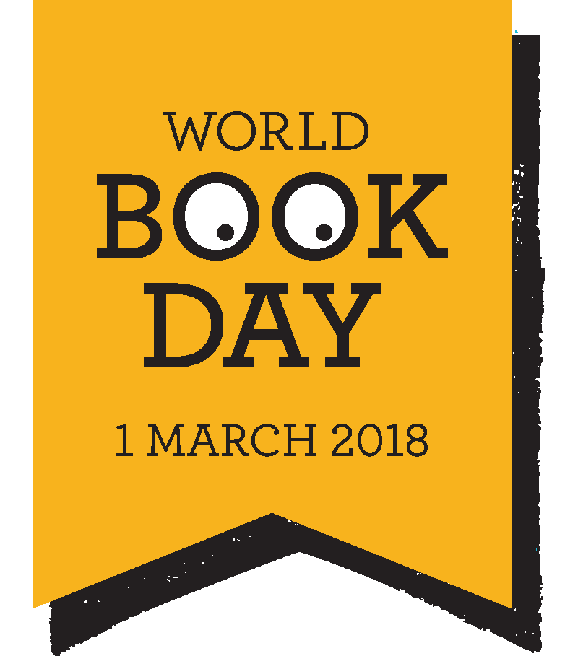
Broomhill Shares a Story
World Book Day
Thursday 2nd March 2018
Many of you are already getting organised at home for World Book Day and once again this year Broomhill will be celebrating.
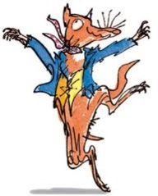
- Come to school in a Book Related Costume, this could be an author, illustrator, character or something else related to books and reading – use your imagination!

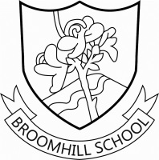
- Reach for the Stars Reading Challenge – each pupil will receive our Reach for the Stars card with 10 different ways to read. The challenge is to complete each star at home (verified by a parent/carer) and return the card to school. Each completed challenge will earn a reward. You could even ask an adult to email a photograph of you completing one of the challenges.

- Share a Story time. During the day we will have a Story Sharing Time with a buddy class, so remember to bring your favourite story to school to share with a friend.

- Individual classes will be involved in various World Book Day Activities throughout the day.

- Each child will receive a World Book Day Token which they can use to buy one of the amazing £1 books on offer at your local book shop.

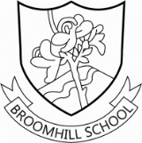
Name:
Read in a cafe
Reach for the stars
Reading Challenge
Can you Reach for the Stars and Read 10 different ways? Colour each star when you’ve completed each challenge and ask an adult to sign each star when complete. You could even add some more stars of your own with other inventive ways to read.
Bring the Challenge back to school to receive an reward.
Read in the car/bus
Read in a comfy spot
Read in your PJs
Read to a pet
Read in the park
Read in the bath
Read at bedtime
Read to a family member
Read to a friend

