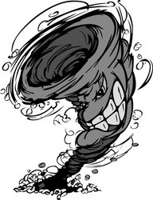
P5 Homework (Room 16) – Stage 5 (3 Words)
Topic - Hazards and Disasters
Next term we will be learning about natural disasters and we will connect this with our learning of the global goals. Your challenge this week is to see if you can find out about one natural disaster which has happened in world in 2017. Include the following:
- The name of the disaster.
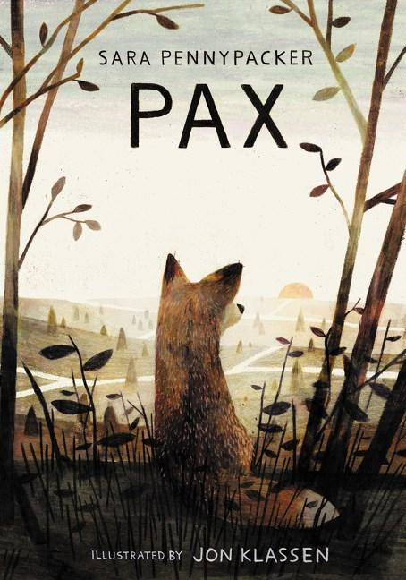
- Where it happened.
- How many people were affected?
- A brief summary of what happened.

Literacy – PAX
Instead of a numeracy task I have given you a literacy task. We will be reading PAX next term in class. Use your inference skills and see if you can predict what the story will be about. Discuss this at home.
Spelling – Use your common words below and choose a spelling task.
name | near | night
nine | ninety | nothing
November | October | road
Saturday | Sunday | September

