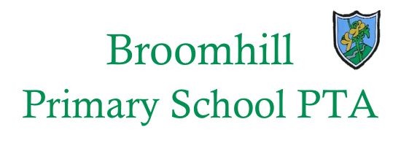
Parent Council

Broomhill School Parent Council Agenda
May 10th 2017 at 7.00 – 8.00pm
(followed by Spring Fayre Meeting)

- Welcome and Apologies

- Minutes of previous meeting

- Headteacher’s Update

- Pupil Equity Funding

- Parent Council Constitution

- Year Representatives

- Out of School Care

- PTA Matters / Social Events / Fundraising

- AOB

